Q. what is c language?
C is high level programming language
Q. what is programming?
Programming means logical thinking of person called as programming.

Q. what is coding?
Coding means if we implement logics for atomization purpose called as coding.

C is high level programming or middle level programming

How to create application using c language
If we want to create application using c language we have following steps.

1) Installed turboc++ as editor
It is editor which provide environment to us for create and execute c program.
https://developerinsider.co/download-turbo-c-for-windows-7-8-8-1-and-windows-10-32-64-bit-full-screen/
Use above link for download turboc++ as editor.

2) Create sample application
if we want to create any program in c language we have following steps.
I) Add header file program
Q. what is header file?
Header file is collection of function in c language.

Q. what is function?
Function is the statements which are used for perform some task.
e.g printf() this statement is used for display output on output screen.

if we want to work with c language we must be add two header files in program
stdio.h,conio.h
stdio: standard input and output header file
conio: console input and output header file.

stdio : standard input and output header file
this file contain functions which is used for accept input from keyboard and provide output
if we want to add header file in code we need to use #include statement

Syntax: #include<filename.h>
e.g #include<stdio.h>
ii) Write main function and its logic.
Q.what is main function?
main function is a heart of c program means without main function we cannot run c program when c program then it will start from main method means we can say main method is entry of program execution.
Syntax: void main (){
Write here your logics
}

Example: WAP to display good morning message on output screen
if we want to display anything on program output screen we have printf() function

Syntax: printf (“message”);
e.g printf(“Good morning”);

printf() is a member of stdio.h header file means if we want to us this function program
we must be include stdio.h header file in program.

#include<stdio.h>
#include<conio.h>
void main()
{ clrscr();
printf("Good Morning");
getch();
}

3) Save application or program
4) Compile program
5) Run program.

Data Type in c language
Q. what is data type and why use it?
Data type means we specify to compiler what kind of data or information we want to use in program
Called as data type.

There are three types of data type in c language
1) Built in Data type: built in data type means those data type provided by c language to us called as built in data type.
There are three types of built in data type
A) integer:
There are four types of integer
I) integer
If we want to work with any data type we must be know four important things.
I) How to use in program: write only int program

ii) How much memory u required: required 2 byte of memory
Q.why 2 byte?
Memory size of data type is depending on compiler.
TCC – 2 byte
GCC – 4 byte
JIT - 4 byte

Can we see memory size of data type?
if we want to see the memory size of data type we have sizeof() operator.
iii) range :Range means value storage capacity of data type or calculation capacity of data type.
-32768 to 32767

iv) Format specifier: format specifier represents a data type in printf and in scanf() function.
The format specifier of integer is %d

ii) Long integer: long integer can store larger type value in it
How to use in program: long int
Memory required: 4 byte
Range:
-2147483648 to 2147484647
Format specifier: %ld
iii) Unsigned integer:
How to use in program : unsigned int
Memory size: 2 byte
Range: 0 to 65535
format specifier : %u

iv) Short Integer:
how to use in program : short int
memory required: 2 byte
format specifier :%d or %i
range: -32768 to 32767

B) Float: floating data type is used for store decimal point values.
There are three types of floating data type
1) Float:
How to use in program : float
Memory required : 4 byte

Range: 38 38
-3.14 x 10 to 3.14 x 10
format specifier : %f

2) Double :
how to use in program: double
memory required: 8 byte
format specifier : %lf
range: 308 308
-1.7 x 10 to 1.7 x 10

3) Long Double:
How to use in program: long double
Memory : 10 byte
Format specifier : %Lf
range: 4932 4932
-1.7 x 10 to 1.7 x 10

C) Character:
The major goal of character data type is to store alpha numeric values.
There are two types of character data type
a) Sign char
How to use in program : char
Memory required : 1 byte
format specifier : %c
range:
-128 to 127
b) Unsigned char
How to use in program: unsigned char
Memory required: 1 byte
Range: 0 to 255
Format specifier: %c
2) User Defined Data Type: those data type defined by user for its own use called as user defined data type.
a) Structure
b) Union
c) enum
3) Derived Data Type: those data type acquire properties of built or user defined data type and complete its meaning called as derived data type.
a) pointer
b) function
c) array
Operator in C Language

Q. what is operator?
Operator is a symbol which is used for perform some operations.
There are seven types of operator in c language

1) Arithmetic operator: it is used for perform arithmetic operations.
Operator | Meaning
+ | Addition
- | Substraction
* | Multiplication
/ | Division
% | Reminder or mod operator
#include<stdio.h>
#include<conio.h>
void main()
{
clrscr();
float a,b,c;
a=11;
b=2;
c=a%b;
printf("\n\n\n");
printf("C =%f\n",c);
getch();
}
If we think about above code we get compile time error because we try to use reminder operator with floating data type but we cannot use reminder operator with floating in c language.

How to calculate reminder of floating data type
_____________________________________________
If we want to calculate reminder of floating data type we have two ways
I) Use fmod () function: fmod () is a function from math.h header file which is used for calculate reminder of floating data type means if we want to use fmod() in program we need to add
math.h header file in program
#include<stdio.h>
#include<conio.h>
#include<math.h>
void main()
{
clrscr();
float a,b,c;
a=11;
b=2;
c=fmod(a,b);
printf("\n\n\n");
printf("C =%f\n",c);
getch();
}

ii) Use type casting or type conversion
Q. what is type casting?
Type casting means if we convert one type of data in to another type for single line of code called as type casting.
#include<stdio.h>
#include<conio.h>
#include<math.h>
void main()
{
clrscr();
float a,b,c;
a=11;
b=2;
c=(int)a%(int)b;
printf("\n\n\n");
printf("C =%f\n",c);
getch();
}

2) Assignment operator: assignment operator is used for assign value from right hand side to left hand side.
Operator | Meaning
= | Assign

3) Relational operator: Relational operator is used for comparison purpose if comparison gets success return 1 otherwise return 0
Operator | Meaning
< | Less than
> | Greater than
== | Equal to
!= | Not Equal to
<= | Less than equal
>= | Greater than equal

#include<stdio.h>
#include<conio.h>
void main()
{ clrscr();
int a,b,c;
a=11;
b=20;
c=a>b;
printf("\nC is %d\n",c);
getch();
}

4) Logical operator: logical operator is used for combine more than one condition and checks it.
Operator | Meaning
&& | Logical AND Operator if we this operator then if all condition are true then condition is true otherwise condition is false
|| | Logical OR Operator if we this operator if any one condition is true then condition is true otherwise condition is false
! | Logical Not operator if true condition then false and if false then true
Note: Every logical operator work as logical Gate
5) Increment or decrement operator: increment and decrement operator means it is short cut of increase value by 1 and decrease by 1
Operator | Meaning
++ | Increment by 1
-- | Decrement by 1
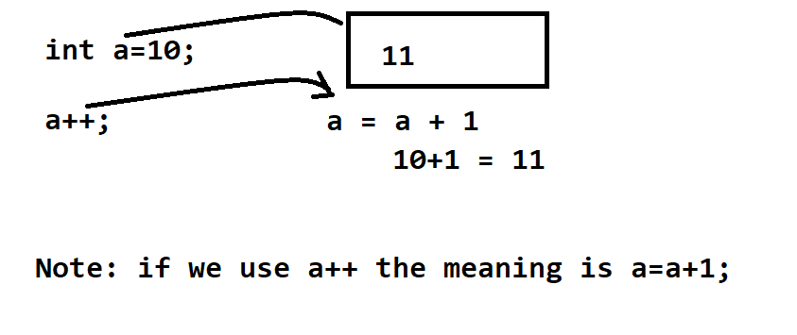
There are two types of increment and decrement operator in c language
a) Pre increment or pre decrement
b) Post increment and post decrement
Post Increment or Post Decrement: if we think about post increment or decrement then first value initialize at left hand side and after that increment or decrement value of variable.

Syntax: variablename op;
e.g b=a++; here we first use variable name and after that we use ++ so it is post increment
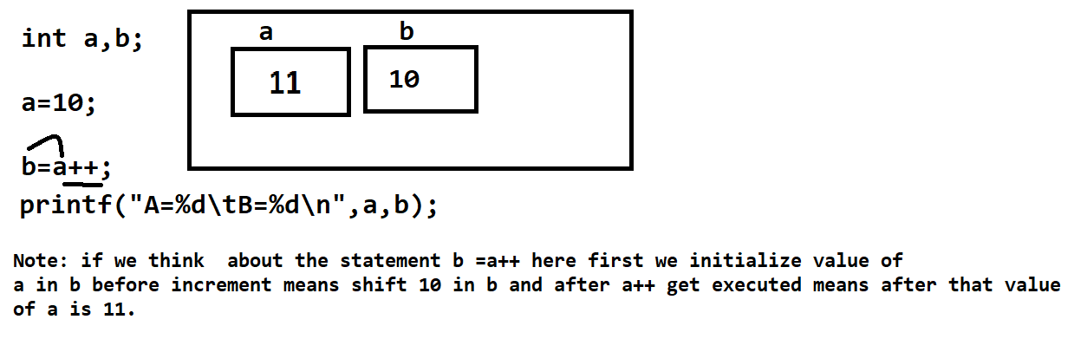

Pre increment and Pre decrement: Pre increment and Pre decrement means first we perform operation with variable and after that we shift its value at left hand side.
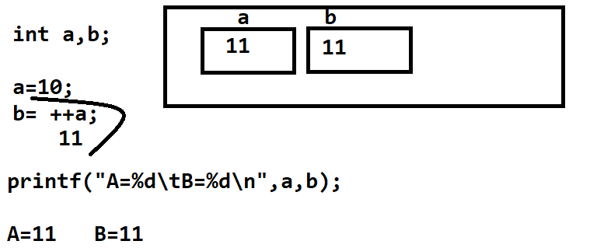

6) Conditional operator: Conditional operator is used for check the condition

Operator | Meaning
? | Ternary Operator
: | Colon operator or option operator

Generalize syntax
exp1 ? exp2 : exp3 ;
Here exp1 is always condition and exp2 and exp3 are the options
if exp1 is true then exp2 get executed if exp1 is false then exp3 get executed.
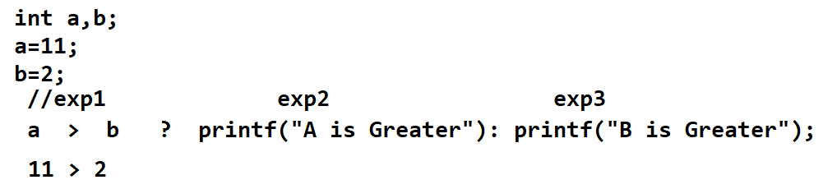
If we think about statement we have expression a > b is exp1 means it is condition and in our example value of a is 11 and value of b is 2 so a>b means 11 > 2 is true condition so c compiler generate 1 so we get result A is greater means exp2 get executed

7) Bitwise operator

Variables and Constant
____________________________________________________________
variable means block of memory which is used for store some data or store data as per his data type basically variable work as identifier in program means in short we can say when we declare variable then memory create block and block size is depend on data type of variable.

How to declare variable
Syntax: data type variablename;
e.g int a;

If we want to work with variable we need to know the some important points or Variable declaration rules.

1) Variable name must be start with alphabet or underscore character
Example: int a; //valid variable name
int _a; //valid variable name
2) Variable name should be start with digit but digit may be come later in variable name
int 10a;//invalid variable
int a10;//valid variable
3) Variable name should be contain special symbol except underscore
int a_b; //valid
int a?b;//invalid variable
4) Capital variable name and small variable name consider
int a,A; //two different variables.

Constant
___________________________________________________________________
Constant means those value never change in code called as constant

Q. what is use of constant?
Reusability of value is a major goal of constant
Types of constant
There are two types of constant
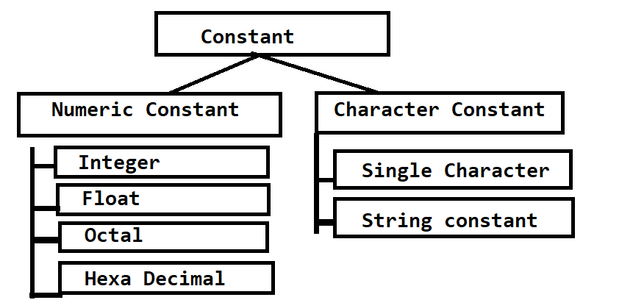

Integer constant means a constant value without decimal point in it called as integer constant
Example: 1,50,60,80,90,100 etc
Float Constant means a constant value with decimal point called as float constant
Example: 5.4,2.4, etc
Octal Constant means value with preceding 0 between 0 to 7 called as octal
Example: 072 – it is octal constant
Hexa Decimal Constant means a value with preceding 0x or 0X and value must be between 0 to 15
After 10 A to F
Example: 0x72; it is hexa decimal constant.

Single character constant: when we have value with ‘‘ single quote then it is consider as single character constant in c language
‘A’ , ‘9’
String constant: when we have value with “ “ double quote then it is consider as string constant.
“good”,

Example: WAP to declare two variable and store values in it and calculate its addition.
Algorithm
1) START
2) DECLARE two variable and store values in it
3) Calculate Addition of two variable and store in third variable
4) Display result
5) END

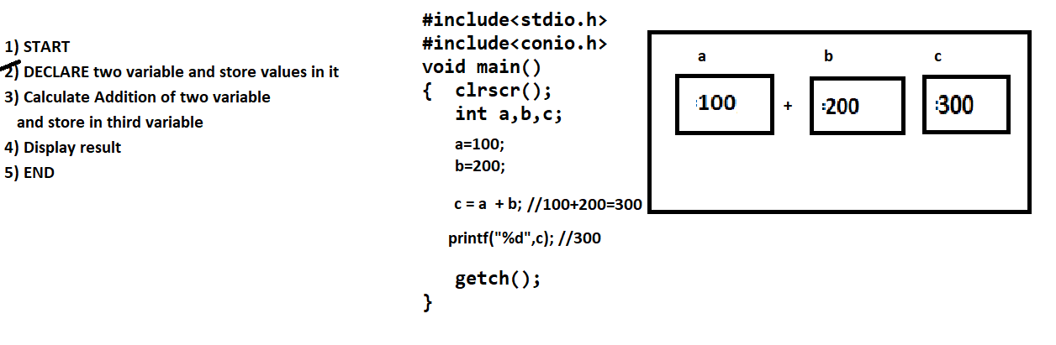

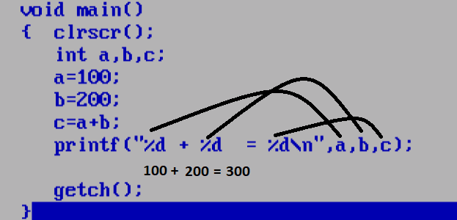

if we think about above code we calculate addition of two numbers but values are fixed so if we want to calculate addition of two different values other than 100 and 200 then we need to open source code or code and change values of a and b and run program but it is not possible every time in real life so we want to input value from keyboard after program run after that we want to calculate its addition for that we have scanf() function.
scanf() function is used for read or accept input from keyboard at program run time
Syntax: scanf(“format specifier”,&variablename);

